1. ➢Hardness- definition, causes, disadvantages
2. ➢ Numerical problems based on hardness calculation
3. ➢ Numerical problems based on alkalinity calculation======87
4. ➢ Determination of alkalinity =87
5. ➢ Cold and Hot LIME-SODA process of water softening with neat diagrams and reactions =53
6. ➢ Complexometric titration method or EDTA method - principle, procedure, uses. =85
7. ➢ Boiler corrosion- reason, chemical reactions, disadvantages, treatment methods =93
8. ➢ Boiler troubles- types- reason, chemical reactions, mechanism involved, treatment methods, disadvantages =31best,89(only pdf)
9. ➢ Differences between foaming and priming in boilers. =44,93
10. ➢ Ion exchange process of water softening- chemical reactions, diagram. =61,94best
11. ➢ Classification of polymers based on their source of origin with examples. =down
12. ➢ Differences between addition polymerization and condensation polymerization with examples. =down
13. ➢ Polymerization process/ synthesis/ preparation, properties, disadvantages and applications of Teflon, PVC, Bakelite, polystyrene.
14. ➢ Classification of polymers based on their thermal behaviour with examples or differences between thermosetting and thermoplastics. 21best,109
15. ➢ Free radical polymerization mechanism- chemical reactions and intermediates involved. =102
16. ➢ Differences between intrinsic and extrinsic conductivity in conducting polymers.
17. ➢ Classification of carbon nanotubes based on their structures.
18. ➢ Differences between single-walled nanotubes (SWCNTs) and multi-walled nanotubes (MWCNTs)
19. ➢ Coordination mechanism involved in the polymerization process- chemical reactions, mechanism, types of catalyst used etc., =chatgpt
20. ➢ Definitions in polymers introduction
21. ➢ Tacticity- importance, polymer classification, examples, types, applications, chemical structures. =10
22. ➢ Conducting polymers- mechanism, reactions, examples, role of doping. =52,down cont

1)☞The property of water to form an insoluble curd with soap instead of lather (foam). ☞A water sample's ability to consume soap, or precipitate soap as a characteristic property.

Causes of Hardness

Hard water contains more number of salts like CaCl2, MgCl2, CaSO4 and MgSO4 etc.

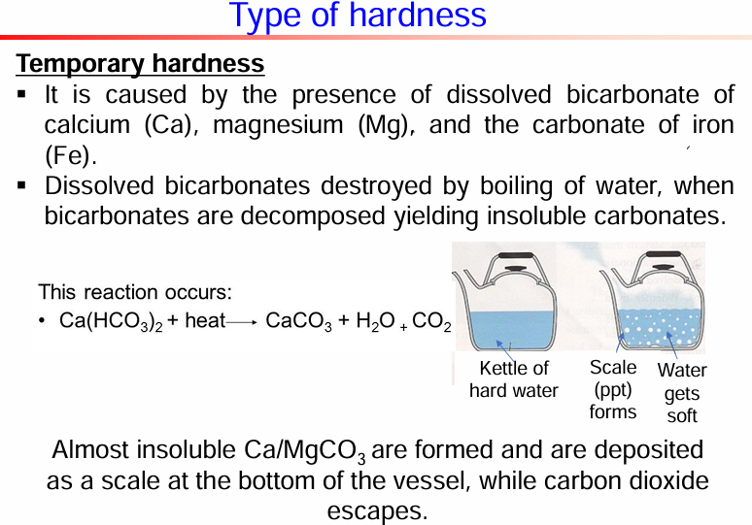

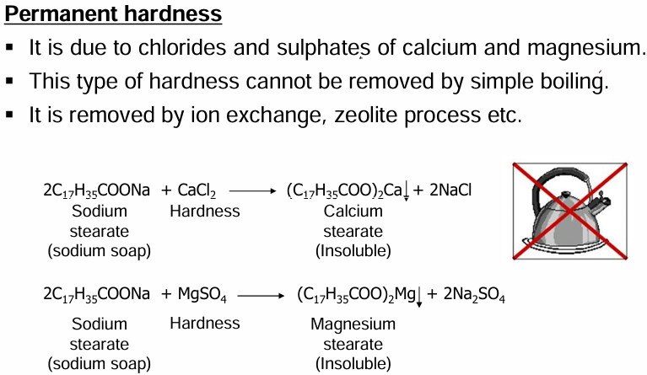

**Numerical problems based on hardness calculation**

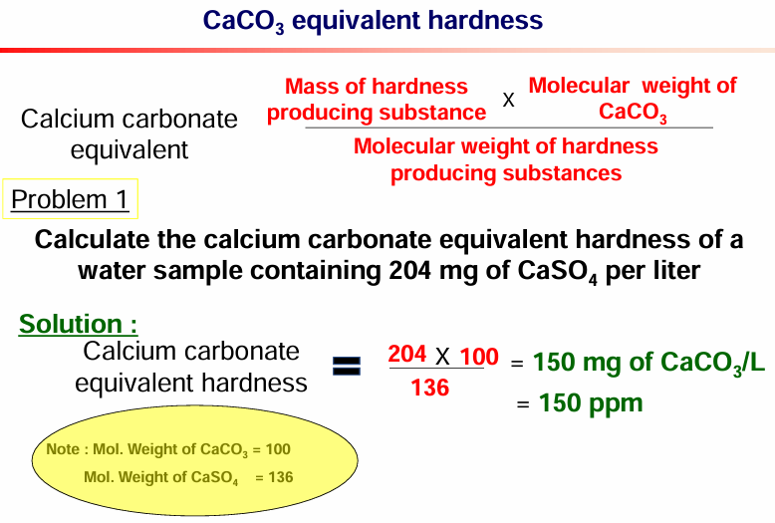

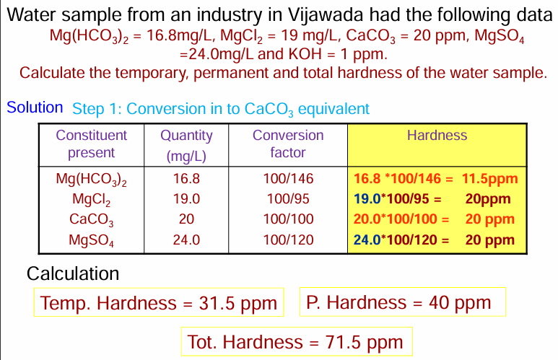

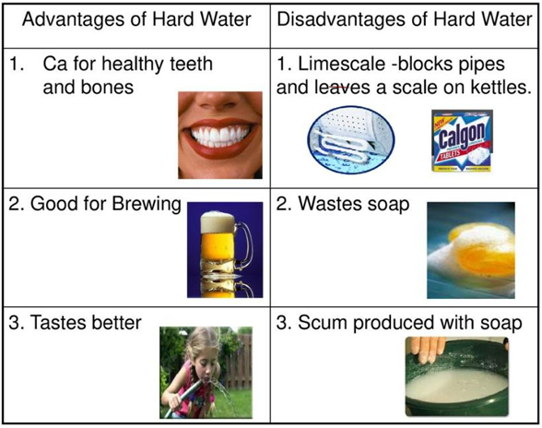

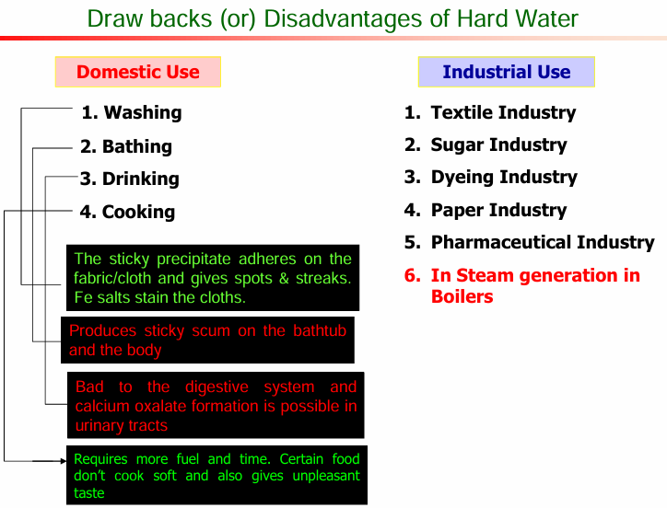

4)Determination of alkalinity

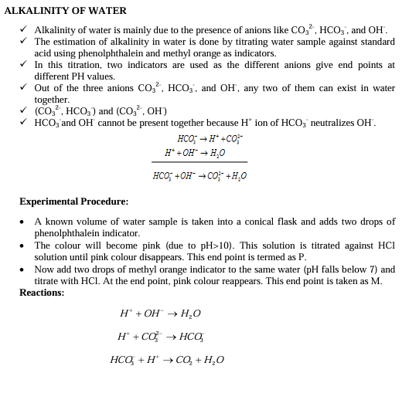

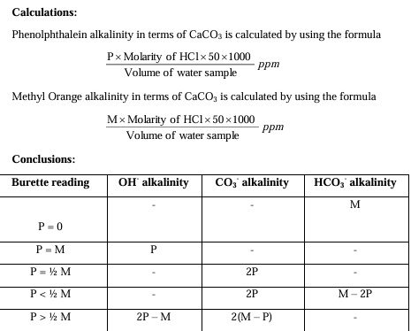

5)

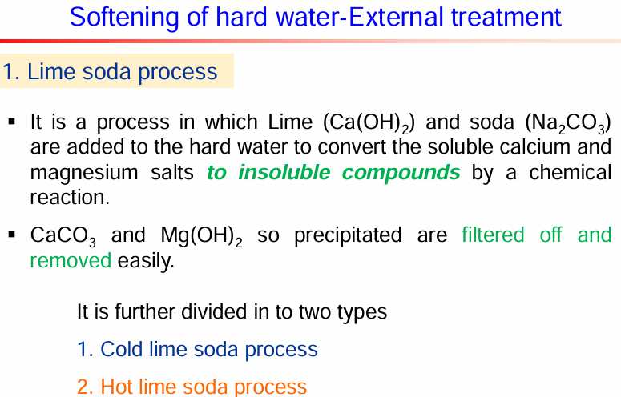

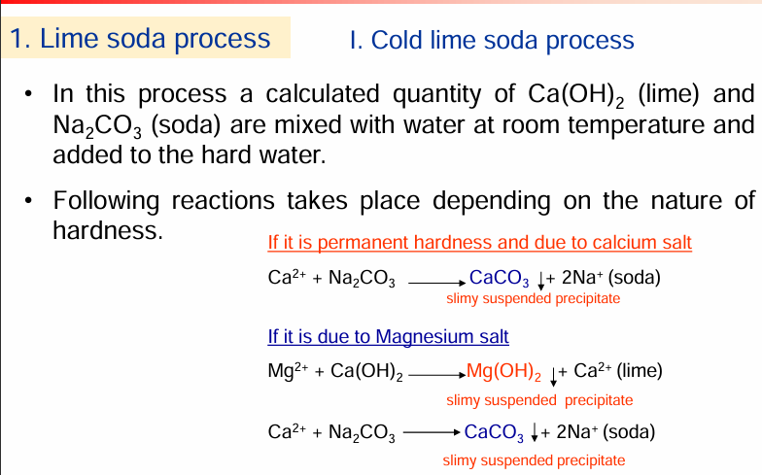

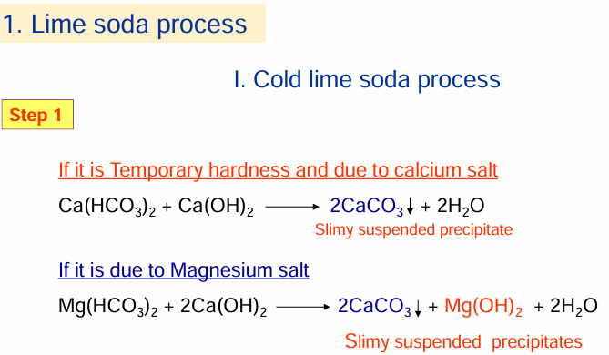

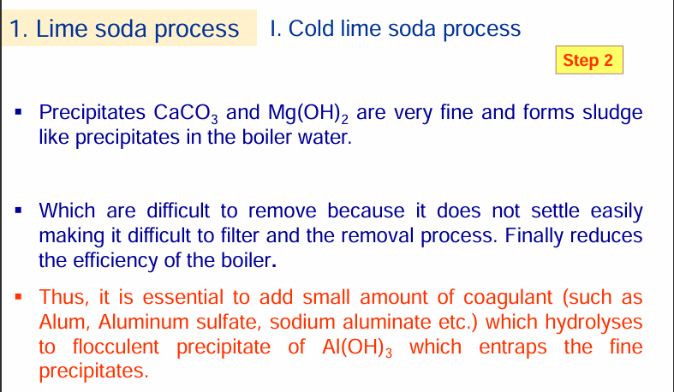

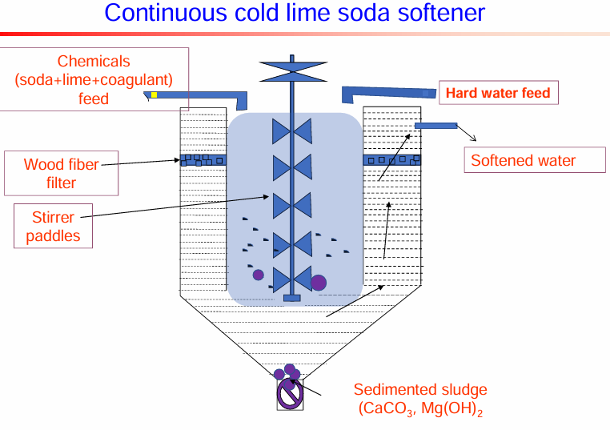

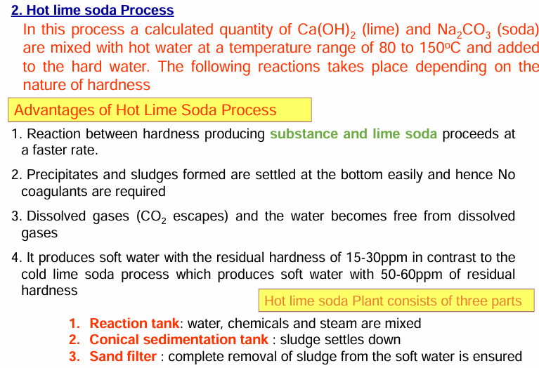

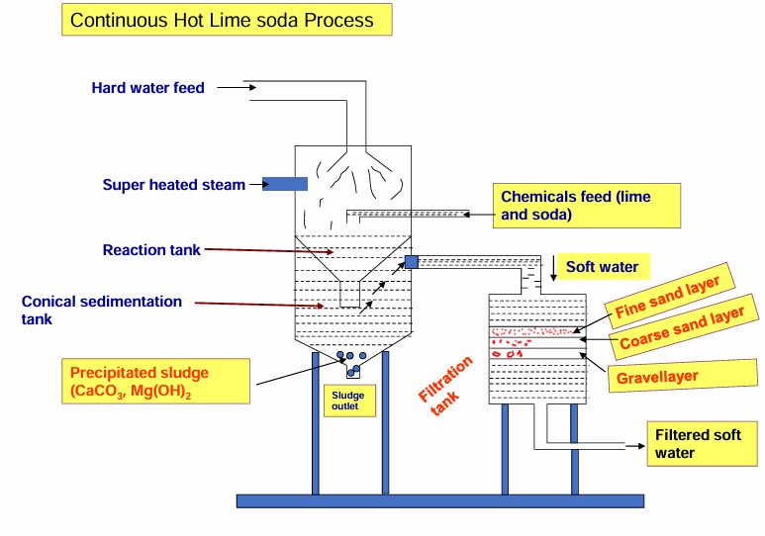

Advantages of Lime soda process

1. It is very economical compared to other methods

2. Iron and manganese salts are also removed by this process

3. It increases the pH of the softened water hence corrosion is minimized also pathogenic bacteria

Disadvantages of Lime soda process

1. Disposal of large amount of sludge (insoluble precipitates) poses a problem

2. This can remove hardness to the extent of 15ppm which is not good for boilers

**6)Complexometric titration method or EDTA method - principle, procedure, uses.**

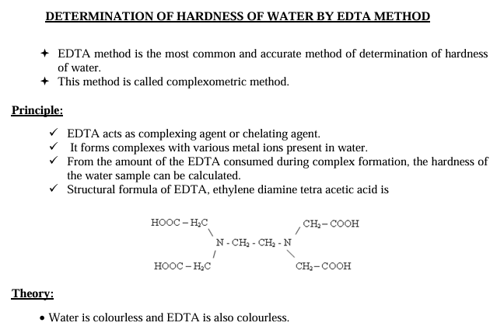

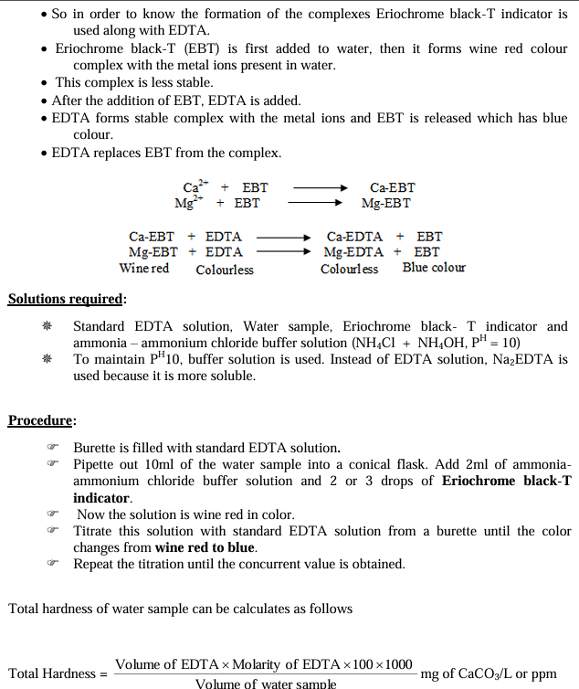

**Uses**

Complexometric titrations are used in many applications, including:

* Determining metal ion concentrations in environmental samples, such as water and soil

• • Analyzing trace metal ions in pharmaceuticals

• • Quality control in the production of food and beverages

• • Monitoring heavy metal pollution in industrial effluents

• • Research in analytical chemistry and metallurgy

7) Boiler corrosion- reason, chemical reactions, disadvantages, treatment methods

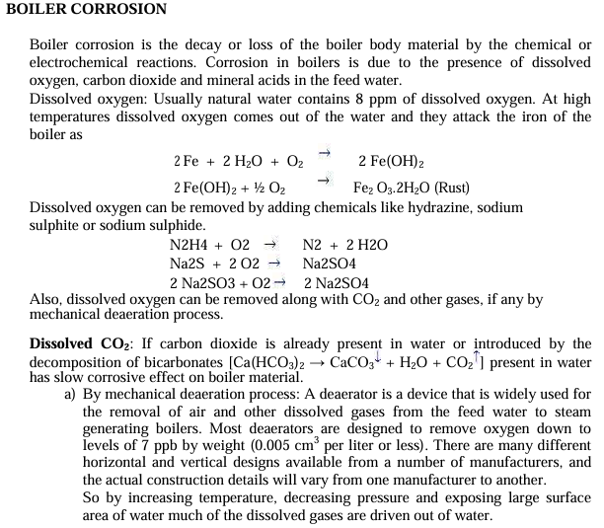

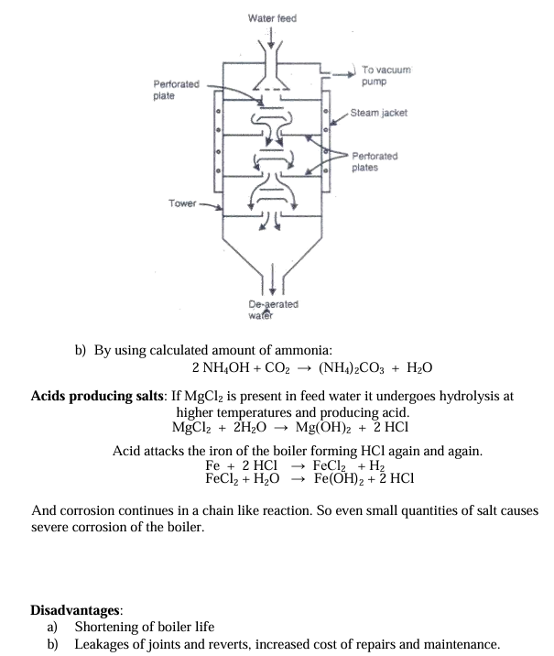

9)➢ Differences between foaming and priming in boilers

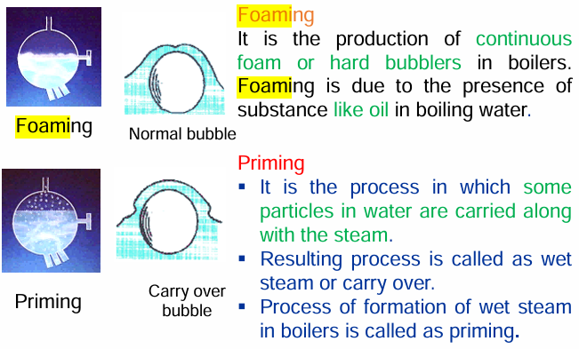

**Causes of Priming ▪**

Very high level of water ▪ Uneven heating ▪ Presence of large quantity of dissolved salts, organic matter, alkalies and suspended matter etc. ▪ Improper design of the boiler. ▪ High steam velocity

**Prevention of Priming** ▪ Maintaining proper water level in the boiler. ▪ Removing dissolved salts and oily matter. ▪ Avoiding sudden changes in temperature. ▪ Proper design of the boiler.

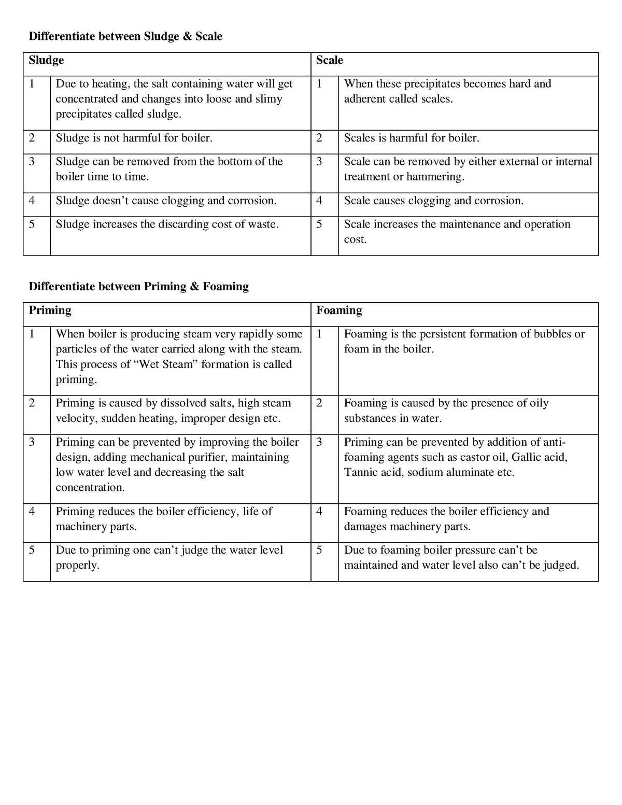

10)

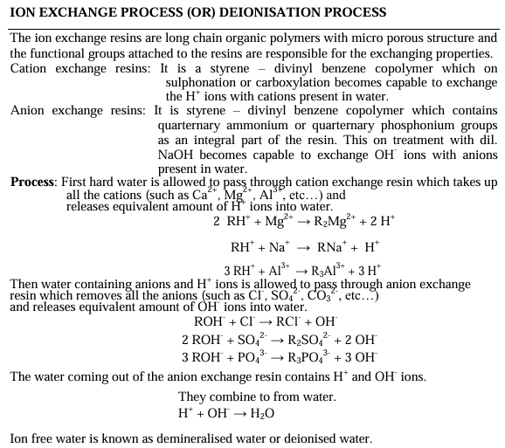

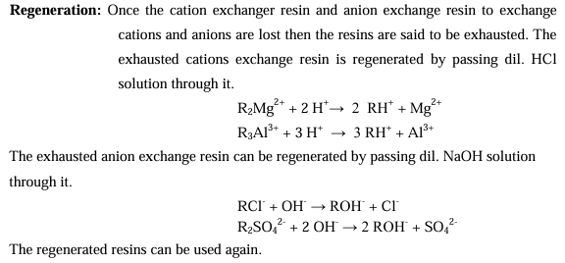

**11)Classification of polymers based on their source of origin with examples.**

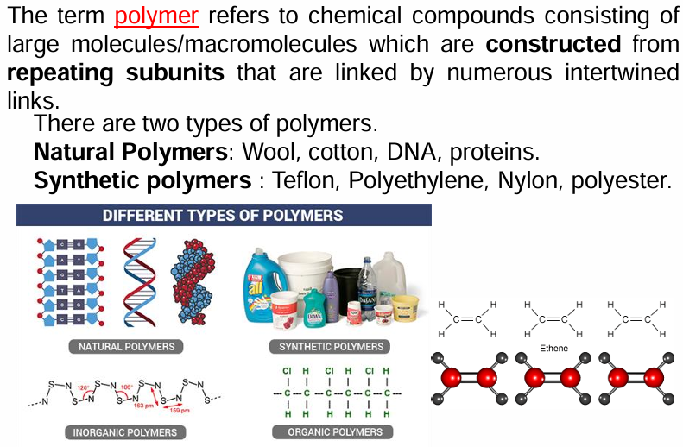

**Natural polymers**

**These polymers are found in nature, such as in plants and animals. Examples include cellulose, starch, rubber, proteins, and nucleic acids. Natural polymers are usually biodegradable and more environmentally friendly than synthetic polymers.**

**• • Synthetic polymers**

**These polymers are created artificially in laboratories using chemical substances. Examples include nylon, polyethylene, polyester, Teflon, and epoxy. Synthetic polymers are more stable and less expensive than natural polymers.**

**• • Semi-synthetic polymers**

**These polymers are made by modifying the properties of natural polymers through chemical treatment. Examples include rayon, cellulose nitrate, acetate rayon, viscose rayon, and cuprammonium silk. Nylon is an example of a semi-synthetic polymer because it is made from both coal and water.**

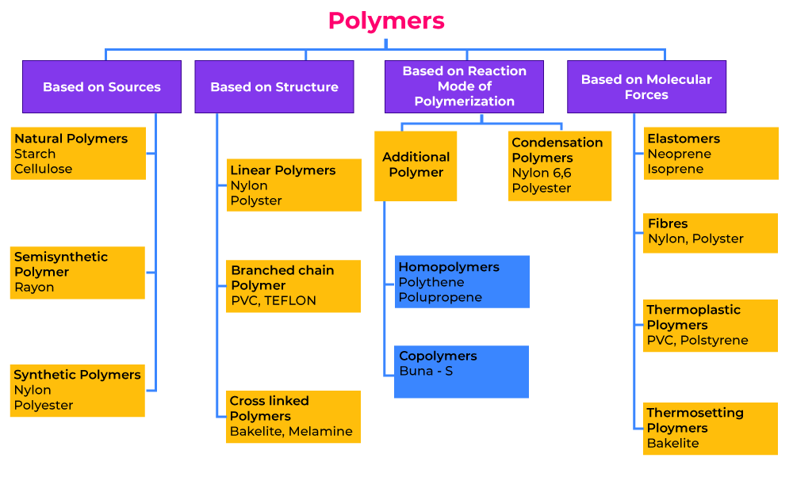

**12)Differences between addition polymerization and condensation polymerization with examples**

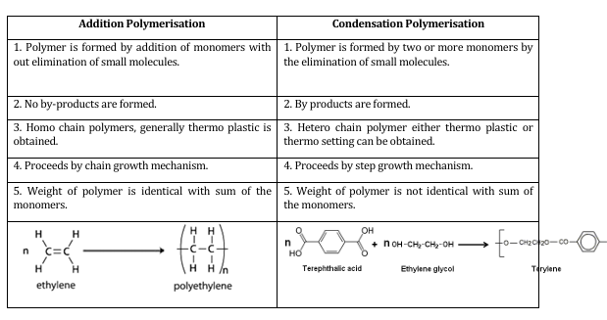

**Here are some examples of addition and condensation polymers:**

* **Addition polymers**

These polymers are made from monomers with double or triple bonds. Examples include:

* + Polyethylene: Made from ethylene monomers at high pressure and temperature

• • Polystyrene: Made from styrene through a free radical mechanism

• • Polyacrylonitrile: Also known as orlon, made from acrylonitrile in the presence of a peroxide catalyst

• • Natural rubber: Made from isoprene, which is a long chain polymer

* **•**

**• Condensation polymers**

These polymers are made from monomers with different functional groups. Examples include:

* Polyester: A condensation polymer

• • Polyamide: Also known as nylon, a condensation polymer

• • Polyurethane: A condensation polymer

• • Polysiloxane: A condensation polymer

• • Bakelite: A synthetic condensation polymer

• • Dacron: A synthetic condensation polymer

• • Urea-formaldehyde: A synthetic condensation polymer

**14)Classification of polymers based on their thermal behaviour with examples or differences between thermosetting and thermoplastics**

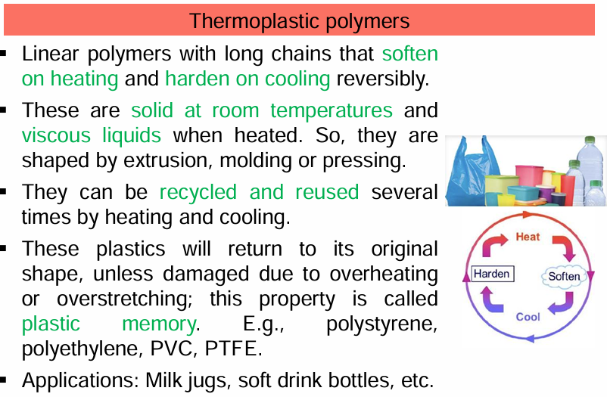

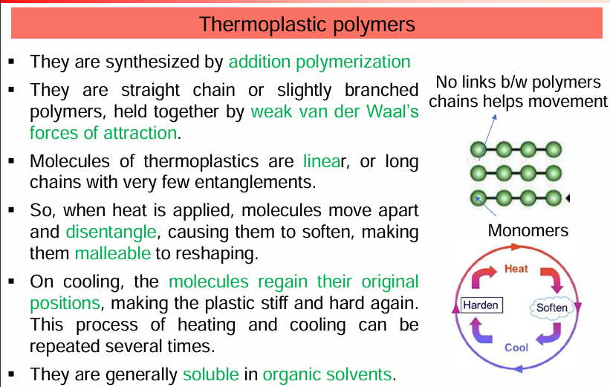

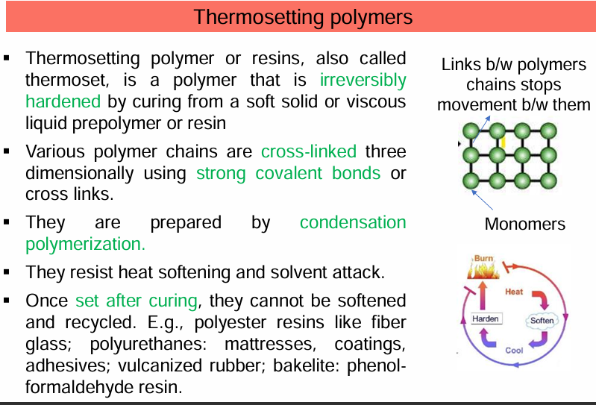

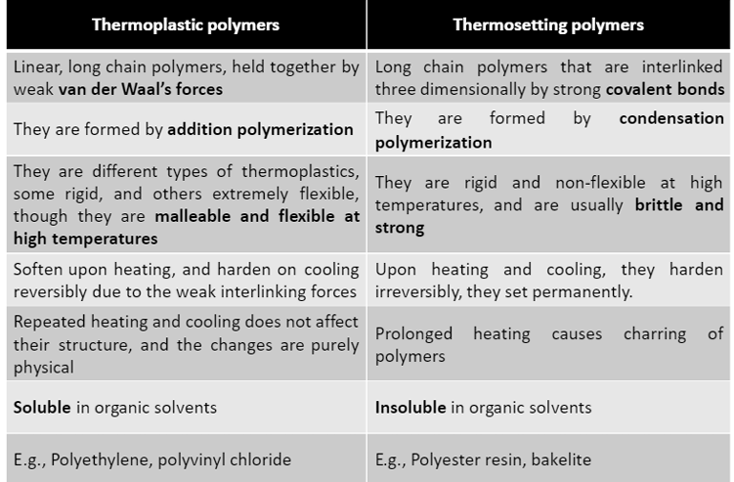

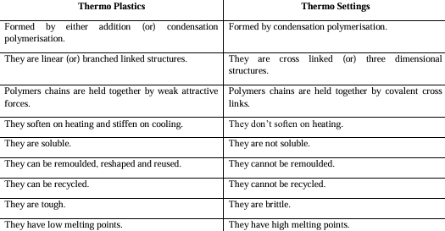

**15)Free radical polymerization mechanism- chemical reactions and intermediates involved.**

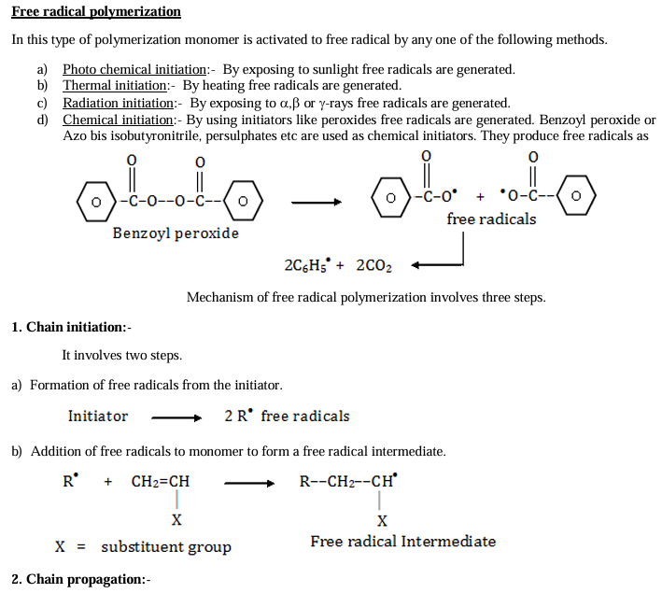

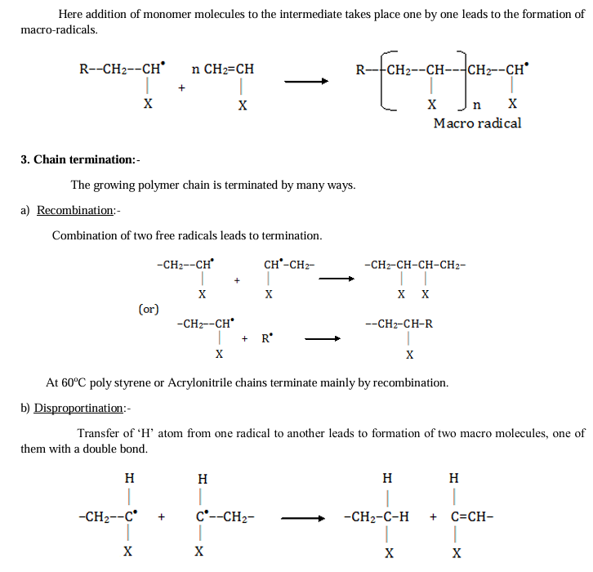



**16)Differences between intrinsic and extrinsic conductivity in conducting polymers.**

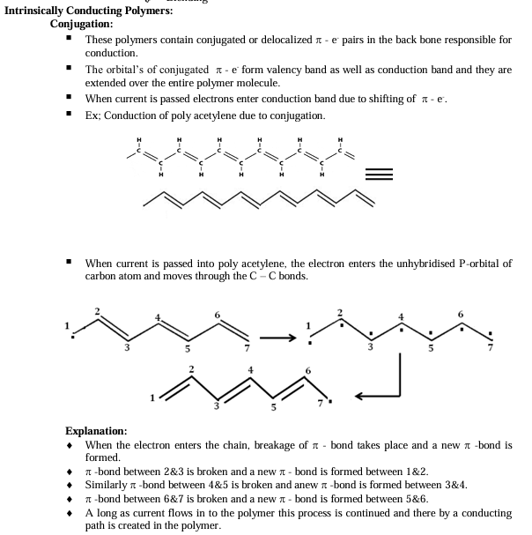

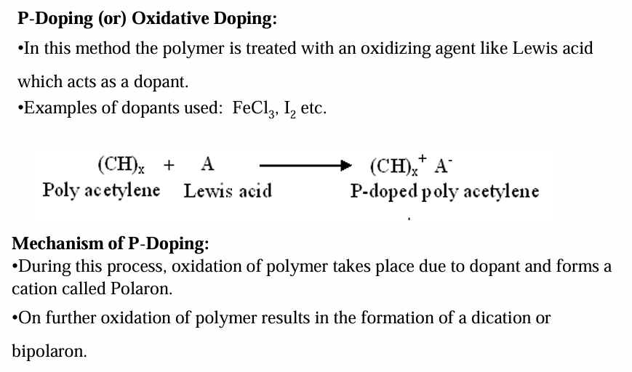

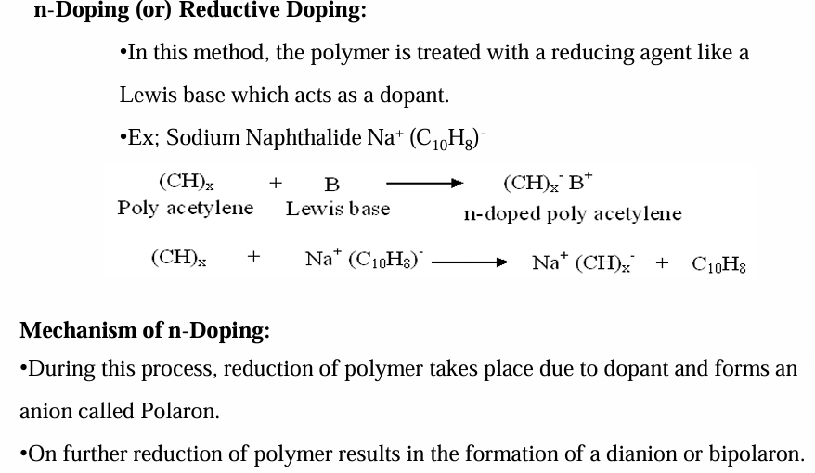

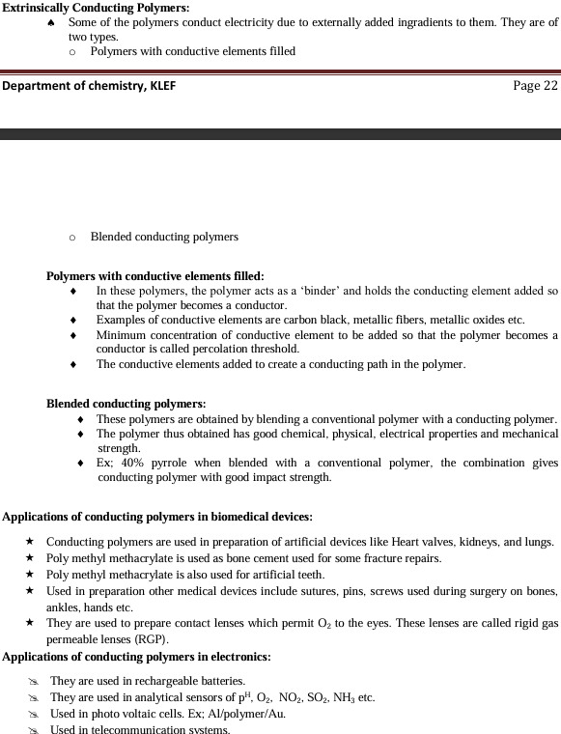



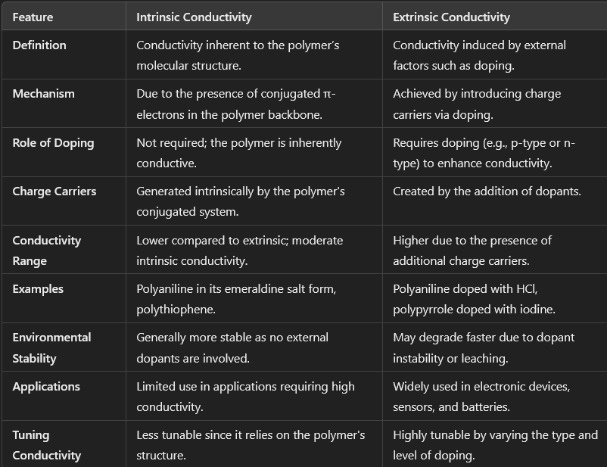

**17)Classification of carbon nanotubes based on their structures**

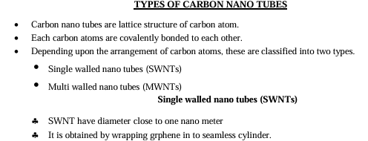

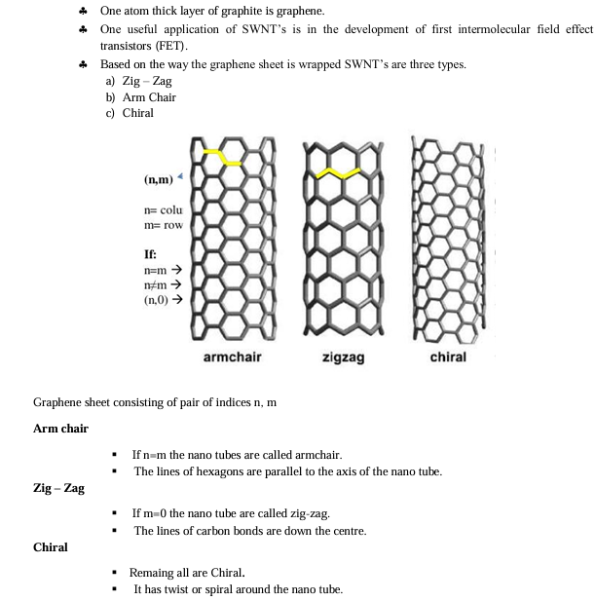

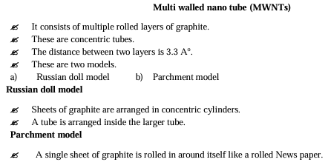

**18)diff**

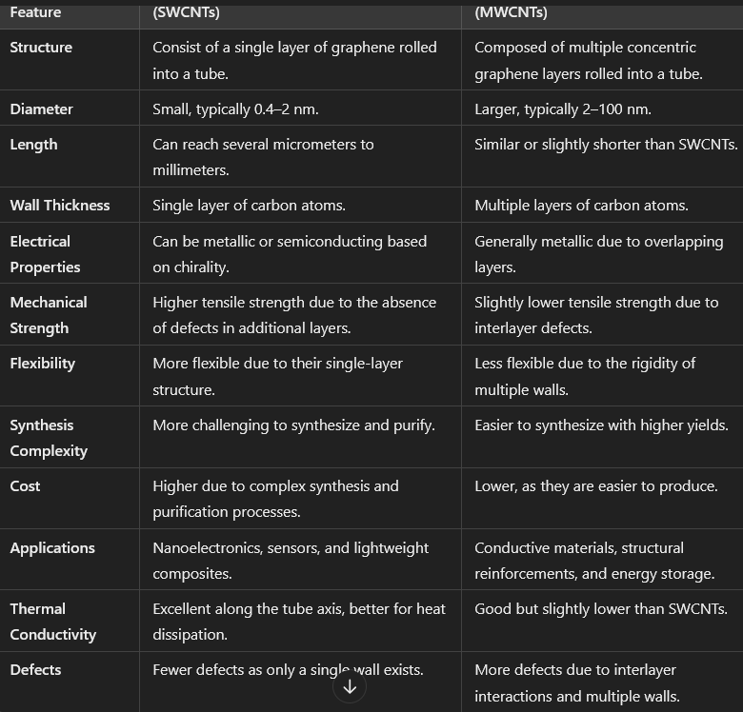

**19)**

**The coordination mechanism in the polymerization process refers to a catalytic system where a coordination complex facilitates the polymerization of monomers. This mechanism is particularly significant in olefin polymerization (e.g., ethylene, propylene). Below are the key aspects:**

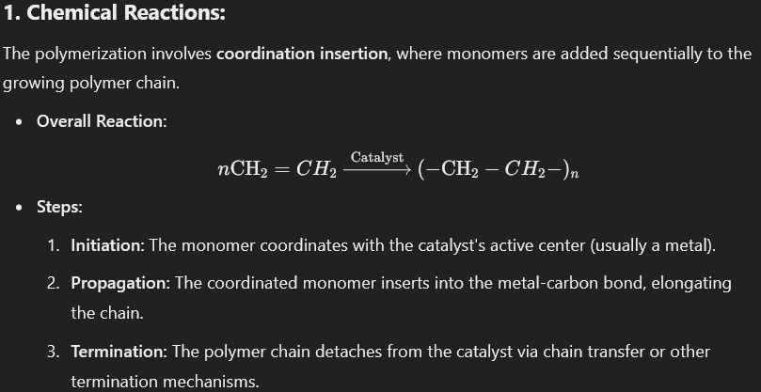

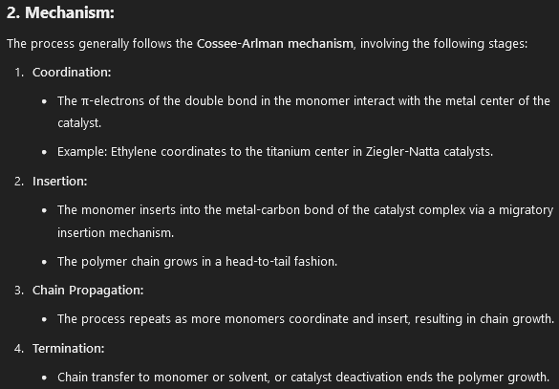

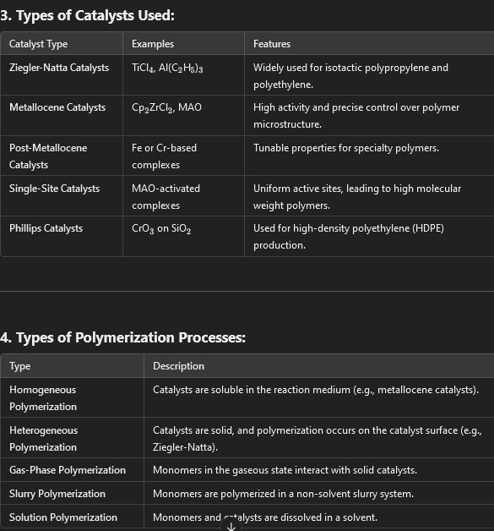

**Applications:**

1. **Polyethylene and Polypropylene**: High- and low-density variations.
2. **Rubbers and Elastomers**: Using specific catalysts for stereoregular polymers.
3. **Specialty Polymers**: Tailored properties for films, fibers, and advanced composites.

This coordination mechanism enables precise control of polymer properties such as molecular weight, branching, and stereochemistry, making it essential in industrial polymer synthesis.

**22)**

**Role of Doping:**

**Doping is the process of introducing charge carriers into the polymer to enhance conductivity.**

1. **Types of Doping:**
   * **p-Type Doping: Removal of electrons (oxidation), creating positive charge carriers (holes).**
   * **n-Type Doping: Addition of electrons (reduction), creating negative charge carriers (electrons).**
2. **Mechanism of Doping:**
   * **Dopants interact with the polymer backbone, introducing charges.**
   * **Example: Acid doping in polyaniline (PANI) converts the insulating emeraldine base form to the conductive emeraldine salt form.**
3. **Dopant Examples:**
   * **Acids (HCl, HNO3_33​): Used for p-type doping of PANI.**
   * **Halogens (I2_22​, Br2_22​): Used for doping polyacetylene.**
   * **Metal salts (FeCl3_33​): Used for doping polypyrrole and polythiophene.**
4. **Effects of Doping:**
   * **Increases the number of charge carriers and their mobility.**
   * **Enhances electrical conductivity by several orders of magnitude.**
   * **Alters optical and electrochemical properties.**

**5. Applications of Conducting Polymers:**

1. **Energy Storage: Batteries, supercapacitors.**
2. **Sensors: Gas sensors, biosensors.**
3. **Electronics: Organic transistors, light-emitting diodes (OLEDs).**
4. **Electromagnetic Shielding: Coatings for EMI reduction.**
5. **Smart Materials: Actuators, wearable electronics.**